|  |
| --- |
| advanced level |
| ***Automobile technology*** |
| Engineering technology |
|  |
|  |
|  |

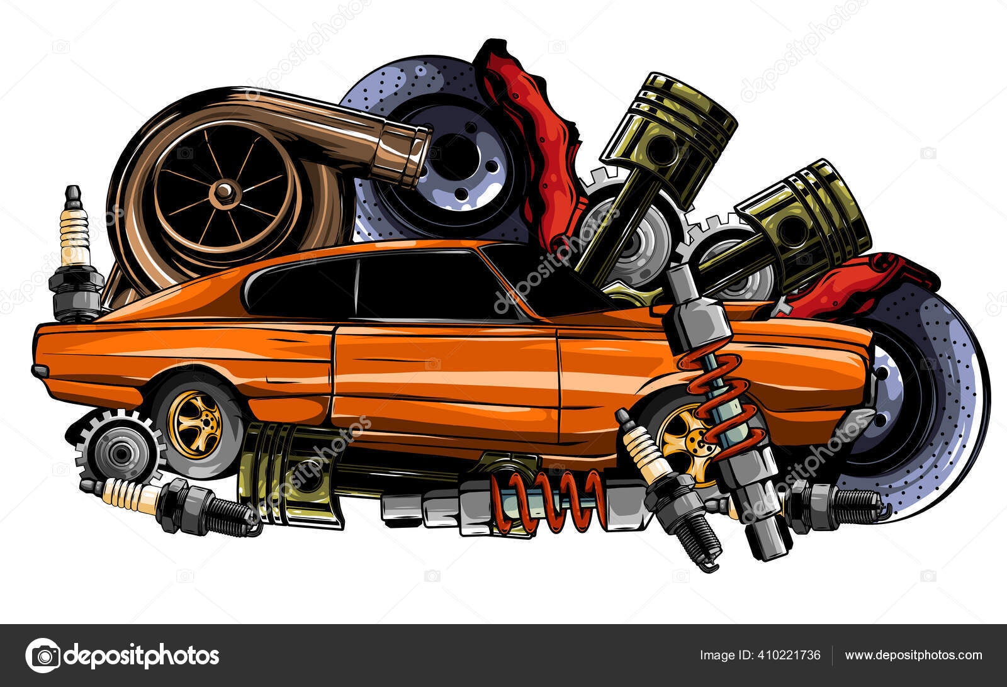

|  |
| --- |
|  |

***Automobile technology***

**The motor vehicle consist with following system**

* Engine
* Transmission system
* Steering system
* Brake system
* Suspension system
* Wheel
* Electrical system

Types of engine

Internal combustion engine External combustion engine

Petrol Diesel steam engine Turbines engine engine

**Definition of internal combustion engine.**

In an internal combustion engine energy supply by a burning fuel is directly converted into mechanical energy by control burning of the fuel in enclose space. The explosive fuel air mixture may be ignited either by an electric Spark by resulting compression temperature in reciprocating in engine the rotation of some engine part by driving the Piston in the cylinder. The motion is transmitted to the crankshaft by means of the connecting rod.

We can classify internal combustion reciprocation engine according to the number of stroke of the Piston in one complete working cycle .Thus, we can speak up to stroke engine and four stroke engine. There is still another classification according to the combustion explosion of constant volume combustion engine and constant pressure combustion or diesel engines.

**IC engine technology**

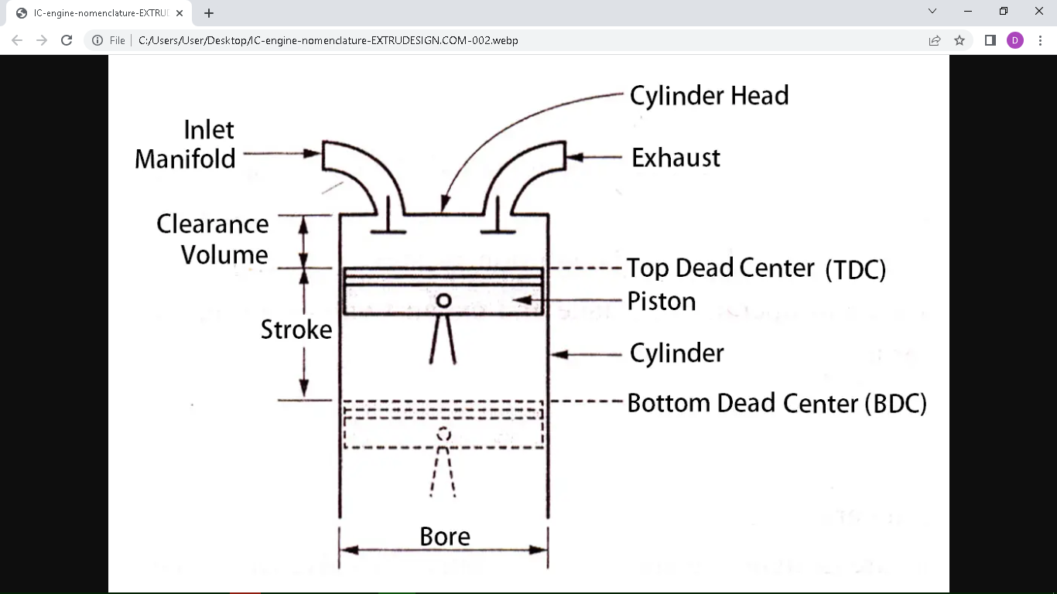

**1) Bore**

The normal inside diameter of the cylinder is called bore.

**2) Top dead centre (TDC)**

The extreme position of the piston at the top of the cylinder of the vertical engine is called top dead centre.

**3) Bottom dead centre (BDC)**

The extreme position of the piston at the bottom level of the cylinder of the vertical engine called bottom dead centre (BDC).In case of horizontal engine. It is known as outer dead centre (ODC).

**4) Stroke**

The distance travelled by the piston TDC to BDC is called as stroke. In other words, the maximum distance travelled by the piston in the cylinder in one direction is known as stroke .It is equal to the twice the radius of the crank.

**5) Clearance volume (VC)**

The volume contained in the cylinder above the top of the piston. When the piston is at top dead centre is called the clearance volume.

**7) Swept volume (VS)**

The volume swept by the piston during one stroke is called the swept volume or piston displacement. Swept volume is the volume coverd by the piston while moving from TDC to BDC.

**8) Compression ratio.**

Compression ratio = maximum cylinder volume

Minimum cylinder volume

= swept volume + clearance volume

Clearance volume

Petrol engine compression ratio is 8:1 – 10:1

Diesel engine compression ratio is 15:1 – 25:1

**Engine components**

**Cylinder block**

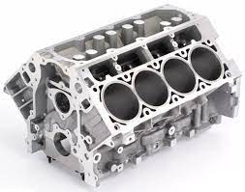

Cylinder block is the main body of IC engine cylinder the is a part in which the intake of fuel, compression of fuel and burning of fuel take place. The main function of cylinder is to grade the system . It is in direct contact with product of combustion. So it must be cool. For cooling of cylinder the water jacket (for liquid cooling used in most of cars) or fin (for air cooling used in most of bikes) are situated at the outer side of cylinder is consisting a combustion chamber where fuel burns. To handle all these pressure and temperature generated by combustion of fuel cylinder material should have high compressor strength. So it is made by high grade cast and it is made by Casting and usually cast in one piece.

**Cylinder head**

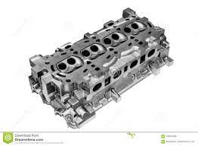

The top end of engine cylinder is closed by means of removable cylinder head. They are two holes or ports at the cylinder head one for in take of fuel and other for exhaust .both the intake and exhaust ports are closed by the two valves known as inlet and exhaust. The inlet valve ,injector, spark plug etc bolted by the cylinder head .The main function of cylinder head is to seal the cylinder block and not to permit entry and exit of gases. I engine cover head is made by cast iron or aluminium alloy.

**Head gasket**

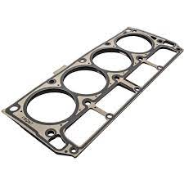Within a water cooled internal combustion engine, there are three fluids which are travel between the engine block and the cylinder head.

1. Combination gases(unburned air/fuel mixture and exhaust gases in each cylinder)
2. Water based coolant in the coolant passages.
3. Lubricating oil in the galleries

Correct operation of the engine requires that each of these circuits do not leak or lose pressure at the junction of the engine block the cylinder head. the head gasket is the seal that prevent these leaks and pressure losses.

**Pistons**

A piston is fitted to each cylinder as a face to receive gas pressure and transmit The thrust to connect in rod. It is a prime mover in the engine. The main function of piston is give tight seal to cylinder through bow and slide freely inside the cylinder. The piston should be light and sufficient strong to handle gas pressure generated by combustion of fuel. So the piston is made by aluminium alloy and sometime it is made by cast iron and because light alloy and expand more than cast iron so they need more clearance to the bore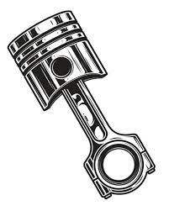.

**Piston rings**

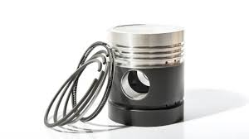The Piston must be fairly lose fit in the cylinder. So it can move freely inside in the cylinder. If the piston is two tightly fit. It would expand as it got hot and might stick tight in the cylinder and if it is to lose it would leaks the pressure to provide a good sealing and less friction resistant between the piston and cylinder, piston are equipped with piston rings these rings are fitted grooves which have been cut in piston.

**Piston rod (connecting rod)**

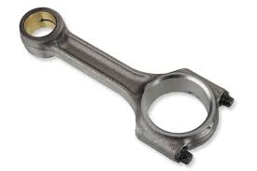Connecting rod connect Piston to crankshaft and transmit the motion of piston into rotary motion of crankshaft. There are two ends of connecting rods one is known as big end and other as small end. In big end is connecting to the crankshaft and the small and is connecting to the Piston by use of piston pins. The connecting rods are made up of Nickel Chrome and Chrome vendium Steel .For small engines the materials may be aluminium.

**Crankshaft**

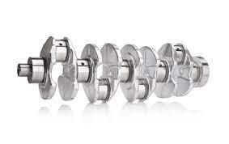The crankshaft of an internal combustion engine receive the effort of thrust supply by Piston to the connecting road and convert the reciprocate in motion of piston motion of crankshaft Mount is bearing so it can rotate freely .The shape and size of crankshaft depend on the number of arrangement of cylinders. It is usually made by Steel forging but some makers. use special type of cast iron such as spheroidal graphite or Nicole alloy casting which are cheaper to produce and having good service life.

**Flywheel**

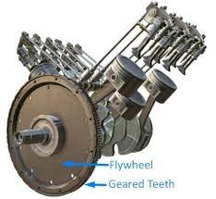A flywheel is required on the crankshaft. The main function of flywheel will is to rotate the shaft during a preparatory stroke . It also make crankshaft rotation more uniform.

**Timing gears**

The purpose of timing gear is to transmit crankshaft of motion to camshaft through timing belt. They are two timing gears one is attached to crankshaft and other one is attached to camshaft the teeth ratio is timing gear attached to the camshaft and timing the attached to the crankshaft is 2:1 therefore whenever crankshaft make 2 revolution the camshaft made only 1 revolution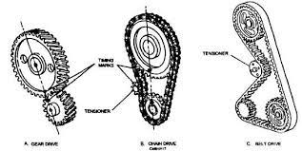.

**Camshaft**

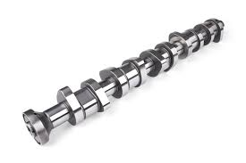Camshaft is used in IC engine to control the opening and closing of valves at proper timing for proper engine output inlet. valve should open at the end of exhaust and close and the end of intake stroke . So to regulate it's timing. A cam is use which is oval in shape and it exerts a pressure on the valve to open and release to close. It is drive by the timing belt which drive by crankshaft. It is placed at the top or at the bottom of cylinder.

**Valve tappet clearance**

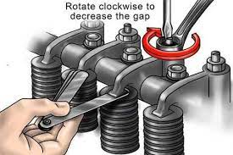Valve tappet clearance is the space between the top of the stem of the valve and the rocker arm when the valves are close position and the engine is at the cold condition at the compression stroke .It purpose is to allow some mechanical expansion and length the valve stem and push rods when the engine warms up.

**Cylinder liners**

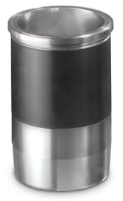liners are cylindrical components that fit inside the cylinder bore .

**purpose of liners.**

1) Liners are provided in order to increase the service life of the IE engine ,wear resistance to bore.

2) It simplifies the production of cast iron engines .

**Materials used for production of liners**

Liners are produced by cast irons and special alloys containing iron , silicon , manganese , nicel and chromium.

There are 2 types of liners called dry liners and wet liners.

* Dry liners are not directly contacted with cooling liquids therefore they called as dry liners .
* Wet liners are having directly contact with cooling liquid therefore they called as wet liners.

**Engine capacity (CC)**

The term “CC” stands for cubic centimeter or simply cm3 which is a meric unit to measure the engine’s capacity or it’s volume .it is the unit of measuring the volume of a cube having a size of 1 cm x 1cm x 1cm . CC is also known as engine’s displacement ; It means the top dead center (TDC) to the (BDC) in the engine’s one complete cycle .The engine volume is also measured in litters corresponding to cubic centimeters.

Stroke

🡨 bore 🡪

Vs

BDC

TDC

* + - * + Ve = Vs n
        + Ve = ( X/4 )D2LN

Where ,

Ve = engine capacity

Vs = cylinder swept volume

L = stroke

D = bore diameter

**Engine fire order**

|  |  |  |  |  |
| --- | --- | --- | --- | --- |
| Crank shaft  Degrees. | Cylinders | | | |
| 1 | 2 | 3 | 4 |
| 180 | Power stroke | Exhaust | Compression | Suction |
| 360 | Exhaust | Suction | Power stroke | Compression |
| 540 | Suction | Compression | Exhaust | Power stroke |
| 720 | Compression | Power stroke | suction | Exhaust |

**Type of IC engine according to the number of strokes**

**Two stroke engine**

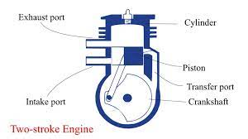

In a two stroke engine a piston moves one time up and down inside the cylinder and complete one crankshaft Revolution during single time of fuel injection. This type of engine has high torque compare to four stroke engine .These are generally used in scooters, pumping sets etc.

**Four stroke engines**

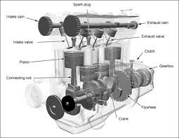

In a four stroke engine pistol most two times of fuel burn. These type engine has high average compared to two stroke engine used in bike cars trucks, etc.

**According to the arrangement of cylinder**

1. **Inline engine**

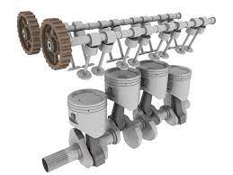

In these type of engine ,cylinders position in a straight line one behind the other along the length of the crankshaft.

1. **V-type engine**

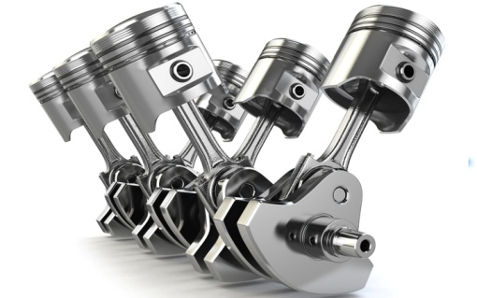

An engine with the cylinder banks include at angle to each other and with one crankshaft known as V-type engine.

1. **Opposed cylinder engine**

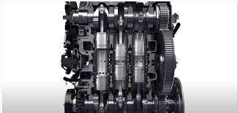

An engine with two cylinder banks opposite to each other on a

Crankshaft ( V-type engine with 1800 angle between banks)

**According to method of ignition.**

1. **Compressed ignition engine**

In this type of engine do not required extra equipment to Ignite the fuel in these engine burning of fuel start to due to temperature rise during air compression.

1. **Spark ignition engine.**

In these type of engine ignition of fuel start by a spark generated in the cylinder by some extra equipment.

In automobile engine there are 4 types of engine according to valve arrangement they are represent as this. L, I ,F ,T, out of these four engine , I headed engine is more popular.

According to air intake process.

1. Normal aspirated

In these type of engines air intake into cylinder occur by the atmosphere pressure.

1. Supper charged engines.

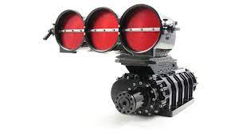

In these type of engine air intake pressure is increased by the compressor driven b the engine crankshaft.

1. Turbocharged engines

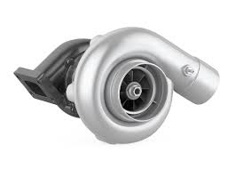

In these type of engine intake of air pressure is increased by use of a turbine compressor driven the exhaust gases of burning of fuel.

**Four stroke cycle in petrol engine.**

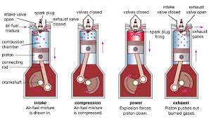

**Intake stroke**

* Piston moves down the cylinder bore from top dead centre to bottom dead centre
* In take valve is open.
* The exhaust valve is closed .
* Downward Piston motion create a vacuum that draws that air/fuel mixture into the engine via the open intake valve.

**Compression stroke**

* Piston moves up the cylinder bore more from bottom dead Centre to top dead Centre.
* Both intake and exhaust valves are closed.
* Upward piston motion compress air/fuel mixture in combustion chamber.

**Power stroke**

* At the end of the compression stroke the spark plug fires and ignite the compressed air/fuel mixture. Explosion forces the piston back down the cylinder bore and rotate the crankshaft propelling in the vehicle forward
* Piston moves down the cylinder bore from top dead Centre to bottom dead Centre.
* Both intake and exhaust valve are close.

**Exhaust stroke**

* Piston move of the cylinder bowl from bottom dead Centre to top dead Centre. The momentum caused by the power stroke is what continuous The crankshaft of movement and the other three stroke consecutively .
* Intake valve is closed the exhaust is open.
* This final stroke forces the spent gases / exhaust out of the cylinder. The cycle is now complete and piston is ready to begin the Intake stroke.

**Two stroke petrol engine.**

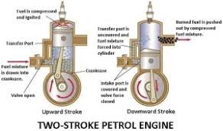

* A two stroke engine is type of internal combustion engine which complete a power cycle with two stroke of piston during only one crankshaft Revolution.
* The two stroke engine employees for small power required in scooters ,motorcycle .In two strokes engine their no suction and exhaust strokes. They are only two remaining stocks the compression stroke and power stock. These are usually called the upward stroke and downward stroke also. Instead of valves, there are inlet and exhaust ports in 2 strokes engine.
* The principal of two strokes spark in ignition engine is shown in the figure. It's two strokes are,

1) Upwards stroke.

2) Downward and stroke.

**Upward stroke**

* During upwards stroke the piston moves upward from the bottom dead Centre to top dead centre. By compressing the charge air- petrol mixture in the combustion Chamber of the cylinder due to upward movement of the piston , a partial vacuum is created in the crankcase.
* And a new charge is drawn into the crankcase through the uncovered inlet port .The exhaust port and transfer port are covered when the piston is at the top dead centre position the compressed charge is ignited in the combination chamber by a spark given by the spark plug.

**Downward stroke**

* As soon as charge is ignited the hot gases compress the Piston which moves downward, rotating the crankshaft thus doing the usual work during the stroke, The inlet port is covered by the Piston and the new charge is compressed in the crankcase. further .downward movement of the piston uncovers first the exhaust port and then the transfer port and hence the exhaust starts through the exhaust port .
* As soon as transfer port is open ,the charge through it is forced in the cylinder . The charge strikes the deflector on the piston crown , rises to the top of the cylinder and pushes out most of the exhaust gases. The piston is now at the bottom dead center position.
* The cylinder is completely filled with the fresh charge, although it is somewhat with the exhaust gases. The cycle of events is then repeated ,the piston making two strokes for each revolution of the crankshaft.

|  |  |
| --- | --- |
| **Petrol engine** | **Diesel engine** |
| This engine works on the base of the auto cycle | It works on the base of a diesel engine |
| In this engine, the ignition process occurs due to the spark provided by a spark plug. | In this engine, ignition occurs due to compression of air fuel mixture . |
| It uses petrol or gasoline as a working fluid. | It uses diesel |
| This engine is efficient | It is most efficient |
| This engine has a low compression ratio. | This engine has a high compression ratio. |
| Use less amount of fuel | It uses low amount of fuel |
| These engine use for small applications like cars, motor cycle ,etc. | These engine are mostly used for heavy duty works like ,buses, trucks and vans etc. |

**Comparison between 4 stroke engine and 2 stroke engines.**

|  |  |
| --- | --- |
| **Two stroke** | **Four stroke** |
| It has one revolution of the crankshaft during one power stroke. | It has 2 revolution of the crankshaft during one power stroke. |
| It generates high torque | It generate less torque |
| It uses a port for the fuel’s cutlet and inlet | It uses valves for the fuel outlet and inlet |
| It has a lesser thermal efficiency. | It is engines result in higher thermal efficiency |
| It has a longer ratio in terms of power to weight | It has a lesser ratio in terms of power to weight |
| It generates more smoke and shows less efficiency | It generates less smoke and shows more efficiency |
| Requires more lubricating oil as some oil burns with the fuel | Requires more lubricating oil |
| Due to poor lubrication, more wear and tear occurs | Less power and tear occurs |
| Engines are cheaper and are simple to manufacture . | Engines are expensive due to lubricating and valves and are tough to manufacture . |
| Engines are basically lighter and noisier | Engine are basically heavier because their flywheel is heavy and less noisy. |

**Valve timing diagram**

In four stroke engine thermodynamics cycle will be completed in the two revolution of crankshaft.4 stroke engine use valves rather than the ports .

ports: The fluid can be operated inwards and outward.

Valve: The fluid can be operated in One direction only .

The closing and the opening of the values will be operated by a camshaft .The cycle of operation a four stroke engine consist of following process.

* Suction or intake stroke
* Compression stroke
* Expansion or power stroke
* Exhaust stroke

In four stroke engine thermodynamics cycle will be completed in the two revolution of crankshaft.4 stroke engine use valves rather than the ports ports : The fluid can be operated inwards and outward. Valve: The fluid can be operated in One direction only .The closing and the opening of the values will be operated by a camshaft. The cycle of operation a four stroke engine consist of following process.

The following theoretical valve time in diagram will illustrate how the event such as the inlet and exhaust valve are open and close in an ideal cycle. See the below theoretical valve timing diagram for the four -stroke engine.

**Valve diagram of four stroke IC engine - low speed and high speed operation.**

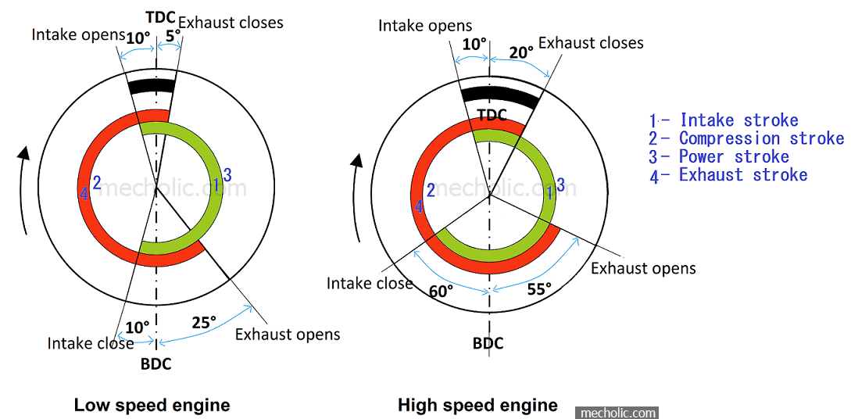

At low speed engine :

Inlet valve opening period = 100+1800+100

= 2000

Exhaust valve opening period = 250+1800+50

=2100

Therefore valves overlapping period = 50+100 = 150

**Engine cooling system**

Combustion of fuel air mixture in the cylinder of an engine generate a large amount of heat. It's about 1500 Celsius to 2000 Celsius at the power stock. The engine doesn't have any ability to convert entire amount of heat generated into mechanical energy .About 40% of guaranteed heat energy is removed by exhaust gases. Another 5% is wasted to remove frictional force generator by engine about 25 of the heat is converted into mechanical energy the balance of 30% of generated heat control by cooling system of engine. If cooling system doesn't work the engine will overheat in a short time. At this moment lubricant oil will burn an high fictional forces occur between the moving parts and parts were out .And also due to excessive heat of engine some engine parts like valves, Piston will expand and got stuck and engine stop working completely.

When the engine is colder than necessary water vapors passing through the Piston rings for the oil chamber and combine with lubricant oil cause rusting of engine components in an over cooled engine gasoline vaporization and combustion will not occur properly. Therefore maximum efficiency of the engine operation the engine should have optimum work in temperature the cooling system should run effectively to archive maximum efficiency of an engine.

**Requirements and types of engine cooling system**

* Air cooled (For small engines a natural air flow)
* Liquid cooling (for large engines)

**Air cooling system.**

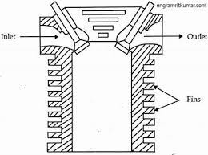

In this method the engine is cooled by passing air current through the engine then the heat generated in engine is absorbed and taken away by directly by a flow for better heat removal more engine outer space should be exposed. Therefore air cold engine increase its outer side imposed area by fixing fins , fins are also made it in the body then know a flow through the engine as for the engine manufacture design.

In a force convection air cooling system a cooling fan is use to provide continues air flow to the engine .There is an exhaust valve to control air flow engine heat rises exhaust valve open and always air of air flow coming in to engine cooled down but this system is not popular because for the multi engine not sufficient to cool in ought.

**Advantages of air cooling system.**

* Production cost is low.
* Most suitable in small and lighter engine.

**Disadvantages of air cooling system.**

Air cooled multi cylinder engine difficult to cool properly and it is also not easy to cool in a high heat .also very noisy

**Liquid cooling system.**

This system having two types of,

* Thermo – syphon method
* Force circulation system

**Thermo - syphon method.**

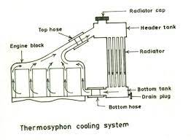The above figure shows the diagram of Thermo - Syphon system .In this system pure water use as cooling liquid. here water flows through the engine water jacket and the radiator due to change in density of the water due to heating when water is heated, It's density in decreases cold water has high density.

As water flow through the engine water Jacket , the water heat up as it absorb heat from the engine then the density of water decreases. Then less dense heated water rises to the top of radiator. As heated water flows through down the radiator the heat in water release and cool by the air stream flowing through the radiator then cold water dense and flows into the engine from bottom hose of the radiator. They are water circulate between engine and radiator and then cools the engine.

For proper operation of the system the entire cooling system must always be fully filed of water. If the water level is low then the water system breaks and system will stop working.

The heat produced in operation of modern engine is very high. They are for the engine must be cool quickly than earlier and also every time the vehicle is driving to get more efficiency from the engine. Therefore temperature should be controlled and kept at maximum optimum working temperature. Also component of cooling system should be small in size for saving the engine space for other equipment installation .Therefore modern vehicle and new system called forced circulation system is produced.

**Forced circulation system**

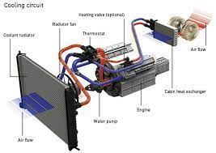The main difference of the system is to introduce of water pump and thermostat for cooling system.

**Component of forced circulation system.**

Coolant :-

Coolant is a mixture of antifreeze (ethylene alcohol) and water (some aluminium radiators have special antifreeze)

* Coolant absorb heat as it passes through the engine and also lubricates the water pump.
* Hot coolant enters the radiator in which the heat is transfured to air that is flowing through the radiator.
* Prevents rust and corrosion from water jackets

**Water jackets :-**

* Design to keep engine block and cylinder head cool.
* Open spaces between the outside of the cylinder and inside of the cylinder block and head.
* When engine is running at normal temperature ,the coolant is forced through the head water jackets in the engine block, through the head gasket ,into the head and back to the radiator.

**Cooling system components water pump (Non positive displacement – impeller type):-** 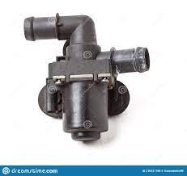

* Draws the coolant from radiator , through the lower horse and then forces it through the water jackets, back into the radiator.
* Water pumps gasket is placed between the water pump and the engine block to prevent leakage .

**Cooling fan**

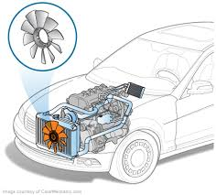

* provides air flows when vehicle is in stationary
* Provides increased air flow at low rpm or vehicle speed

Electric fan is mounted on the radiator is operated by the battery power,

* Is controlled by the thermostat switch.
* Is located on the thermostat housing, block or radiator.
* Some modern cars have the range between 1930 to 2070 F (89 to 970C)
* On A/C equipped cars . a second fan is mounted on and it runs any time A/C is turned on.

**Radiator.**

* Heat exchanger which transfers heat from coolant to the atmosphere
* Two types – vertical and cross flow
* Vehicles equipment with automatic transmission has transmission cooler build into the radiator.
* Aluminum, brass, copper cores; brass, copper or plastic tanks.
* Air movement through radiator created by mechanical fan or by vehicle movement dissipates heat.

**Thermostat**

**.**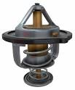

* Placed between the cylinder head to top radiator hose.
* Regulates engine coolant temperature
* The temperature that the thermostat opens is called thermostat rating (85-900C most common )
* Solid expansion design – wax pellet expand as temperature increased valve begins opening at rating and is completely open within 100  if it falls in open position, engine runs cold resulting poor mileage and high wear and tear.

If it falls closed , creates temperature in the engine well beyond it’s limits . many types of damages may occur.

**Hoses**

Top radiator hose bring s the coolant back to the radiator and are molted specifically for individual make a model.

Lower radiator hose draws the coolant into the engine .From the radiator and is attached to the water pump

**Radiator pressure cap**

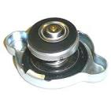

* Most cap exert 10-16 pHs: (0.7 -1.1 kg/sqcm) of pressure
* Each psi of pressure inserted increased the boiling point of coolant by 1.80C
* Built I pressure relief valve prevents excessive pressure build up by sending excess coolant to the expansion tanks.
* Vacuumed vent valve allows the re enters the system (when engine shut off and cools)

The radiator cap allows the engine’s coolant to expand and contact without allowing air to enter the cooling system .the upper seal seals and protect the system after the engine warms and system at all times. Rated pressure, the pressure spring compress and pressurized coolant flows into the reservoir or coolant overflow tank. It allows for the expansion of the heated fluid.

The radiator cap also allows the coolant to flow back into the radiator as the engine cools .it also contains a vacuumed valve .As temperature drop the coolant contacts a vacuum valve opens and allows coolant to flow from the overflow tank back into the radiator .This valve allows for construction as the fluid cools

**Coolant recovery tank.**

1. Keep the coolant level fill in the system in all the time
2. Works in conjunction with the radiator cap
3. When the engine heat up the coolant expands and flows to the recovery tank.
4. When the engine cools the coolant contracts and create a vacuum and draws the fluid back into the radiator.
5. Reduce the air flow in the system
6. Reduces rust
7. Less need to open radiator

**Engine lubrication system.**

The method of reducing the friction by introducing the substances called lubricant between the muting part is called lubrication.

**Objectives**

* Reducing friction thus increase efficiency .
* Reducing wear and tear of moving parts .
* Carry away heat .
* Provides sealing action between cylinder and the piston rings thereby it reduce blow by.
* Provide protection against corrosion.
* Carrying away the grit and other deposits and provide cleaning .
* Reduce the noise.

**Types of lubricants**

* Solid (ex:-graphite molybdenum , Mica)
* Semi – solid(ex:- heavy greases)
* Liquid (ex:- Mineral oil , vegetable oils, animal oils)

**Properties of lubricants.**

* Viscosity
* Cloud point
* Pour point
* Flash point
* Fire points
* Oiliness
* Carbone residue
* Detergency
* Foaming

**Classification of lubrication dbase on rating**

SAE rating

Society of automotive engineers assigned the number for gradationof oil based on their viscosity at -180c (5W , 10W , 15W) and 990C (20W, 30W , 40W, 50w)

API service rating

* American petroleum institute classified the oil based on their property into three groups regular , premium and heavy duty type based not quality and performance of oil.
* Petrol engine :- SA , SB , SC , SD , se
* Diesel engine:- CA , CB , CC , CD , CE
* A, B stands for light duty vehicles and naturally aspirated while DE stands for heavy duty and supercharged.

**Mist lubrication system (petrol)**

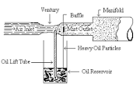

* Employed in 2 stroke petrol engine .
* In this system, the petrol and lubricant oil are previously mixed in fuel intake of from where it is supplied to the carbonator.
* Proportion 2 to 3 %
* It provides lubricating to cylinder, piston, piston ring and connecting rod bearing via the crankcase.
* Also the separated lubrication is provided to those parts of the engine where the mixture of oils and petrol can’t reach or in case it gives unsatisfactory lubrication.

**Advantages**

* Economical and cheap.
* No oil pump, filter and oil carrying pipe needed.
* Quantity of oil is automatically regulated with load and speed.
* Probability of lubrication failure are last

**Disadvantages**

* Carbon deposit during the burning of oil film.
* Fouling of sparkplug, increases maintain cost.
* Oil consumption is high; rather the engine is usually over oiled .
* During long duration of an load due to almost closed throttle valve, engine mating parts may not get adequate lubricant oil.

**Splash lubricating system.**

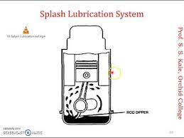

* In this system a scoop is fitted at the bottom of connecting rod and every revolution of crankshaft , scoop is dipped in the oil and then splashed the oil on engine components.
* It is one of the cheapest method of engine lubrication system which is generally use in small 4 stroke engine.

**Force feed system**

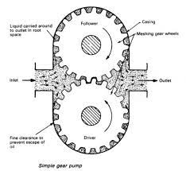

In this system, the oil is pumped directly to the crankshaft , connecting rod ,piston pin ,timing gears and camshaft of the main gallery , which may be a pipe or a channel in the in the main end bearing of connecting rod through drilled holes in the crankshaft from the pipes . it goes to lubricate the walls , piston and rings . There is separated oil gallery to lubrication timing gears . lubricating oil pump is positive displacement pump. Usually gear type or vane type. The oil also goes to value stem and rocker arm shaft under pressure through an oil gallery.

The excess oil comes back from the cylinder head to the crankcase. The pump discharges oil into oil pipes ,oil galleries or ducts, leading different parts of the engine. This system is commonly used on high speed multi – cylinder in tractors, trucks and automobile.

**Simple gear pump parts.**

**Oil pump .**

Oil pump is usually a gear type pump ,used to force oil into the oil pipe. The pump driven by the camshaft of T engine . The lower end of the pump extend down into the crankcase which is covered with a screen to check foreign particles . A portion of the oil forced to oil filter and the remaining oil goes to the lubrication part of the engine. An oil pressure gauge fitted in the line, indicates the oil pressure gauges indicates no pressure in the line, there is some defects in the system in the system which must be checked immediately

**Oil filter**

Lubricating oil in an engine becomes contaminated with various materials such as dirt, metal partials and carbon. Oil filter removes the dirty elements of oil in an effective way .it’s a type of strainers using cloth, papers, felt, wire screen or similar elements some oil filter can be cleaned by washing but in general lid filters are replaced by new filters at specific interval of time pre-described by manufactures. Wearing of parts, oil consumption and operating cost of an engine can be considerably reduced by proper maintain of oil filters.

**Crankcase ventilation.**

* The pressure inside the combination chamber is high so small amount of gases escapes through gap between piston ring and cylinder and enters into the crankcase.
* These gases can dilute and contaminates the engine oil, caused corrosion to critical part and contribute to sludge built up .
* At high speed , blowing gases increased crankcase pressure that caused oil leakage from sealed engine surface and consume some expansion work.
* The crankcase ventilation system removes these blow by gases from crankcase and reduces the pressure of crankshaft .

**Engine Fuel system**

**Introduction**

The fuction of the fuel system is to store fuel and deliver it to the cylinder chamber where it can be mixed with air, vaporized and burned to produce power. The fuel, which can be either gasoline or dieser, is stored in a fuel tank. A fuel pump draws fuel from the tank through fuel lines and pumps it through a fuel filter to either a carburetor or fuel injector and then in to the cylinder chamber for Combustion.

**Engine fuel**

Engine fuel is mainly made up or hydrogen and carbon, mixed So that it will burn with oxygen present, and will free it's heat energy into mechanical energy Liquid fuels are ideal for internal combustion engines, because they can be economically Produced, have a high heat value per found an ideal rate of burning, and can be easily handled and stored. The most Common engine fuels are gasoline, kerosene and diesel fuel ell

**Octane Rating**

A gasoline's ability to resist detonation is called it's 'octane' or anti-knock rating. Gasoline from asphaltic base crude oil Produces less knock than one from Paraffinic base crude Cracked gas has less tendency to knock than straight run gas. All marketed gasolines are a blend of Straight run and cracked gasolines, so useless their blending is controlled, the anti-knock qualities will vary.

A mixture of iso-octane, which has a very high anti-knock rating, and heptane, which makes a pronounced knock, IS used as a reference fuel to establish an anti-knock standard. The anti-knock value or octance number is represented by the Percentage of Volume of iso-octance that must be mixed with normal heptane in order to duplicated the knocking of the gasoline which is being tested. These rating range from 50 in third grade gasoline to 110 in aviational fuels. The rating of 100 means a fuel having an anti-knock value equal to that is iso-octane.

If the Octane rating of a gasoline is naturally law, the fuel will detonate as it burns and power will be applied to the Pistons in hammer-like blows. The ideal power is that which Pushes steadily on the pistons, rather than hammer agaist them. The Octance rating of a gasoline Can be raised by treating it with a chemical which is not a fuel. The best Chemical known is tetra-ethyl lead compound, which is added to the gasoline.

**Carburetor Based fuel system Components**

**Fuel tanks.**

* Fuel tanks Store fuel in liquid form. The tank may be located in any part of a vehicle that is protected from flying debris. Shielded from collisions, and not likely to bottom out. Most to heeled vehicles use removable fuel tanks.
* Most fuel tanks are made of thin sheet metal coated with a lead-tin alloy to prevent corrosion Fiber glass and a Variety of molded plastic are also popular as Corrosion-resistant materials.
* The walls of fuel tanks are manufactured with ridges to give them strength and internal baffles that increase internal Strength and prevent the fuel from Sloshing - The filler pipe offer a convenient opening to fill the tank and Prevent fuel from being spined on to the passenger, engine or cargo components.

**Fuel filter.**

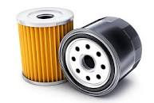

clean fuel is important because of the many small jets and passages in the Carburetor and openings, in a fuel injector To ensure this cleanliness, fuel filters are installed in the fuel line fuel filters can be located at any point between the fuel tank and carburetor one may be in the tank itself in the fuel pump or the carburetor. The most Common placement Is between the fuel tank and a mechanical fuel pump. In 1 this case, the fuel enters a glass bowl and passes up through the filter Screen and out through an outlet. Any water or Solid material which is trapped by the filter will fall to the bottom of the glass bowh where it can be easily seen and removed dirt particles usually come from Scales of rust in the tank cars, Storage tanks or drums. water comes from Condensed moisture In the fuel tanks.

**Fuel pump**

The fuel pump has three functions, to deliver enough fuel to Supply the requirements of an engine under all operating Conditions to maintain enough pressure in the line between the carburetor and the pump to keep the fuel from boiling, and to prevent Vapor lack

.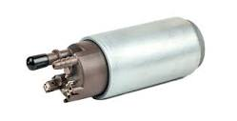

**Air cleaners**

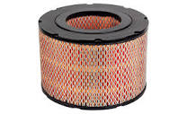

Air cleaners are made of seperate dust and other particles in the incoming air before it enters the carburetor. Thousands of Cubic feet of air are drawn from within the car hood and passed through the engine cylinders, so it is Important that the air is clean.

**The carburetor**

